Title: Visual cortex hyperexcitability in migraine in response to sound-induced flash illusions
Brighina F, MD^{1*}, Bolognini N, PhD^{2,3,4}*, Cosentino G, MD¹, Maccora S¹, MD, Paladino P, MD¹, Baschi R MD¹, Vallar G^{2,3,4}, MD, Fierro B, MD¹.

1:Department of Experimental Biomedicine and Clinical Neuroscience (BioNec), University of Palermo, Palermo, Italy
2:Department of Psychology, University of Milano Bicocca, Milano, Italy
3:Laboratory of Neuropsychology, IRCSS Istituto Auxologico Italiano, Milano, Italy
4:Milan Center for Neuroscience, Milano, Italy

Statistical analysis was performed by Nadia Bolognini
*:These authors equally contributed to the manuscript

Corresponding author:
Filippo Brighina, MD
Department BioNeC, University of Palermo
Via G. La Loggia, 1; 90129, Palermo, Italy
Tel: ++390916555108; Fax: ++390916555127
Email: filippobrighina@gmail.com
AUTHORSHIP AGREEMENT
Dr F. Brighina: drafting/revising the manuscript, study concept and design, data collection, analysis and interpretation of the data
Dr N. Bolognini: drafting/revising the manuscript, study concept and design, analysis and interpretation of the data
Dr G. Cosentino: study concept and design, revising the manuscript, acquisition of the data, interpretation of the data
Dr. S. Maccora: revising of the manuscript, data collection, interpretation of the data
Dr P. Paladino: revising of the manuscript, data collection, interpretation of the data
Dr R. Baschi: revising the manuscript, data collection, interpretation of the data
Prof. G. Vallar: study concept and design, interpretation of the data, revising of the manuscript
Prof. B. Fierro: study concept and design, interpretation of the data, revising of the manuscript

STUDY FUNDING This work was supported by the following research funds: FAR (G.V., N.B.) and Ricerca Corrente IRCCS Italian Auxological Institute (G.V.).
Disclaimer:
This is the peer reviewed version of the following article: Visual cortex hyperexcitability in migraine in response to sound-induced flash illusions, which has been published in final form in Neurology (2015 May 19;84(20):2057-61. doi: 10.1212/WNL.0000000000001584).

ABSTRACT
Objective: Sound-induced flash illusions depend on visual cortical excitability. In this study, we explored whether sound-induced flash illusions are perceived differently in migraine, a condition associated with pathologic cortical hyperexcitability. Methods: Sound-induced flash illusions were examined in 59 migraine patients (mean age: 32 ± 16 years; 36 females), 32 without aura and 27 with aura, and in 24 healthy controls (mean age: 42 ± 17 years; 16 females). Patients were studied during attacks and interictally. Visual stimuli (flashes) accompanied by sounds (beeps) were presented in different combinations: a single flash with multiple beeps was given to induce the perception of multiple flashes (“fission” illusion), and multiple flashes with a single beep were used to reduce the number of perceived flashes (“fusion” illusion). Results: For migraineurs, the fission illusion was reduced, especially during the attack, and almost abolished when a single flash was combined with 2 beeps (except for those without aura tested interictally); the fusion illusion was less consistently reported in both migraine groups, but not completely disrupted. Conclusions: Results from this study add novel clues to our understanding of visual cortex hyperexcitability in migraine, especially migraine with aura. Furthermore, these analyses underscore how pathologic changes in cortical excitability affect multisensory interactions. Cross-modal illusions represent a valid tool for exploration of functional connectivity between sensory areas, which likely has an important role in the pathophysiology of migraine.
Introduction
A powerful example of cross-modal interaction between senses¹ is the sound-induced flash illusion.² When one flash is accompanied by multiple beeps, it is perceived as multiple flashes (the fission illusion); conversely, fewer flashes than those actually presented are reported when coupled with a single beep (the fusion illusion).^{3,4} A recent study of transcranial direct current stimulation (tDCS) in healthy participants showed that the fission illusion can be disrupted by increasing the excitability of the primary visual cortex with anodal stimulation, or by decreasing the excitability of the superior temporal cortex using cathodal stimulation.⁵ Accumulating evidence indicates that cortical hyperexcitability has a prominent role in the pathophysiology of migraine. Rats knocked-in with genes of familiar hemiplegic migraine show cortical hyperexcitability and increased susceptibility to cortical spreading depression (CSD),⁶ namely, a wave of depolarization, followed by hyperpolarization, that spreads slowly across the cortex.⁷ CSD is one of the pathophysiologic bases of migraine aura. CSD-like changes in fMRI signals⁸ and in magnetic evoked fields9 have been described during migraine aura in humans. Abnormal cortical excitability (especially in the visual cortex) was also detected in the interictal phase in migraineurs, suggesting it as a basic dysfunction in migraine.^{10–12} Thus, we explored the sound-induced flash illusions in migraineurs, in order to evaluate how abnormal (visual) cortical excitability affects perception of these cross-modal illusions.
METHODS
Standard protocol approvals and patient consents. The ethics committee of the University of Palermo approved this study and all participants gave their written informed consent. We abided by ethical standards of the Declaration of Helsinki (BMJ 1991;302:1194).
Participants. Fifty-nine patients affected by migraine (mean age: 32 ± 16 years; 36 females), 32 fulfilling diagnostic criteria for migraine without aura (MwoA) and 27 for migraine with aura (MwA) according to the International Headache Society Classification (2013)¹³ (a mean of 3.1 ± 1.4 and 2.9 ± 1.3 migraines per month, respectively) were consecutively recruited at the Headache Center of the University of Palermo, Italy. Nineteen MwoA and 19 MwA patients were examined interictally (at least 48 hours since last migraine); of these, 13 MwoA and 8 MwA patients were studied during a migraine (within 3 hours after aura). These patients were not taking any migraine prophylaxis medication or other drugs known to affect cortical excitability. Patients were compared with a group of 24 neurologically healthy controls with no personal or familial history of headache (mean age 42 ± 17 years; 16 females). Patients and controls were all right-handed, and had normal or corrected-to-normal vision and normal hearing. Participants were naive to the aim of the research. Stimuli and procedure. We used the same stimuli and procedures from a previous study.⁵ Briefly, we tested participants in a dimly illuminated room; patients sat approximately 57 cm from a CRT computer monitor (Samsung SyncMaster 1200NF: resolution 1,024 x 768, refresh rate 75 Hz) with their eyes aligned to the center of the screen and their head supported by a chinrest. Each trial began with the appearance of a white fixation cross, displayed at the center of the black screen (luminance 0.02 candela [cd]/m2 ). At the eccentricity of 5° of visual field, a white disk subtending 2° was flashed 1 to 4 times. Two speakers, delivering the auditory stimulus, were positioned near the screen, and aligned with the flashes. The task comprised 11 experimental conditions: single flash trials (1F), accompanied by 0 to 4 beeps (B) (i.e., 1F0B, 1F1B, 1F2B, 1F3B, 1F4B) to induce the “fission” illusion. We used multiple flash trials (i.e., 2F, 3F, 4F), accompanied by 0 or 1 beep (2F0B, 3F0B, 4F0B, 2F1B, 3F1B, 4F1B) for the “fusion” illusion. Each flash (luminance: 118 cd/m2 ) and beep (intensity 80 dB sound pressure level) lasted one screen refresh (13 milliseconds [ms]). The first flash appeared 26 ms after the first beep. We used a stimulus onset asynchrony of 65 ms (5 refreshes) between flashes, and 52 ms (4 refreshes) between beeps (see figure 1). Eight trials were presented in random order for each experimental condition (total number of trials: 88; task duration: approximately 5 minutes). For each trial, we instructed participants to report the number of flashes perceived. Before the experiment, we presented 10 practice trials to study participants, which were not considered in the analyses.
Statistical analyses. To assess the fission illusion (i.e., the increment of reported flashes when we presented multiple beeps, compared with 0- and 1-beep trials), we analyzed participants’ mean perceived flashes in 1-flash (1F) trials (combined with 0–4 beeps, 0–4B) using repeated-measures analysis of variance (rmANOVA), with the between-subjects factor group (5 levels: controls, MwoA patients tested in the interictal or ictal phases, MwA patients tested interictally or ictally) and the within subjects factor beep (5 levels: 1F0B, 1F1B, 1F2B, 1F3B, 1F4B). To assess the presence of a fusion illusion (i.e., number of perceived flashes on multiple flash trials when 1 beep was presented, compared with 0-beep trials), we analyzed the participants’ mean perceived flashes for every flash trial (from 1 to 4 flashes, combined with 0 or 1 beep) using rmANOVA, with the between-subjects factor (group) and the within-subjects factors beep (2 levels: B = 0–1) and flash (4 levels: F = 1–4). We conducted post hoc multiple comparisons using Bonferroni tests and assessed effect sizes by calculating the partial eta squared (pƞ2) to measure the proportion of total variance attributable to a main factor or to an interaction.¹⁴
RESULTS
Fission illusion. In the presence of a single flash, increasing the number of beeps resulted in an increase in perceived flashes, namely, the fission illusion; this illusory effect was lower in patients with migraine compared with controls (figure 2). The rmANOVA analyses showed a main group effect (F_{4,83} = 4.67, p < 0.01, pƞ2 = 0.28): during a migraine for MwoA (1.47, p < 0.02) and MwA (1.43, p < 0.01), these patients reported fewer flashes compared with controls (1.79). In contrast, we did not detect a difference between controls and MwoA (1.62, p = 0.5) or MwA (1.55, p = 0.06) patients, or between the 2 patient groups (p > 0.6) when patients with migraine performed the task during an interictal period. The main beep effect (F_{4,16} = 205.33, p < 0.0001, pƞ2 5 0.71) demonstrated the fission illusion, that is, when we presented more than 1 beep, participants reported perceiving more than 1 flash (1F2B = 1.71, 1FB3 = 1.99, 1F4B = 2.12) compared with the 0-beep trial (1F0B = 1.12, p < 0.001 for all comparisons) and the 1-beep trial (1F1B = 1.07, p < 0.001 for all comparisons). Of note, we also identified a group by beep interaction (F_{16,332} = 3.28, p < 0.0001, pƞ2 = 0.24). We explored this interaction via 5 one-way ANOVAs, one for each stimulus condition, with group as a between subjects factor. For the 1FB0 and 1F1B conditions, we found no effects (F_{4,83} = 0.36, p = 0.8, pƞ2 = 0.02; F_{4,83} = 0.49, p = 0.7, pƞ2 = 0.02). In contrast, we found effects for every illusory condition. In particular, for the 1F2B condition (F_{4,83} = 4.45, p < 0.01, pƞ2 = 0.38), compared with healthy controls (1.96), only MwA patients showed disruption of the fission illusion during the attack (1.5, p < 0.01), but not interictally (1.65, p = 0.06); results from MwoA patients did not show reduced illusion during the interictal (1.67, p = 0.9) or the ictal (1.61, p = 0.06) phases. No differences emerged between migraine patient groups (p > 0.8). For the 1F3B condition (F_{4,83} = 4.17, p < 0.01, pƞ2 = 0.41), compared with controls (2.3), results showed decreased fission illusion in MwoA (1.78, p < 0.03) and MwA (1.71, p < 0.01) patients when tested during migraine, but not during the interictal phase (MwoA: 2.05, p = 1; MwA: 1.88, p = 0.07); there were no differences between migraine patient groups (p > 0.6). For the 1F4B condition (F_{4,83} = 4.65, p < 0.01, pƞ2 = 0.39), MwoA patients showed reduced illusory effects (1.88, p < 0.03) during migraine, but not during the interictal phase (2.23, p = 1), whereas for MwA patients, we found reduced illusory effects (1.71, p < 0.01) during both the ictal (1.77, p < 0.01) and the interictal (1.98, p < 0.05) phases. We did not observe any difference between the 2 migraine groups (p > 0.2).
Fusion illusion. On multiple flash trials, participants reported perceiving fewer flashes when 1 beep was presented compared with the 0-beep trials (figure 3). The beep effect (F_{1,83} = 38.64, p < 0.0001, pƞ2 = 0.32) demonstrated the fusion illusion (0B trials = 2.51 vs 1B trials = 2.32). The flash effect (F_{2,166} = 469.38, p < 0.0001, pƞ2 = 0.85) indicated that more flashes were perceived when more flashes were presented (p < 0.01, for all comparisons). Finally, we identified a significant group-beep-flash interaction (F_{8,166} = 3.97, p < 0.001, pƞ2 = 0.25). Other effects did not reach significance: group (F_{4,83} = 1.12, p = 0.4, pƞ2 = 0.05), beep-flash (F_{2,166} = 0.002, p = 0.9, pƞ2 = 0.01), group-beep (F_{4,83} = 2.36, p = 0.06, pƞ2 = 0.1), and group-flash (F_{4,166} = 0.85, p = 0.6, pƞ2 = 0.4) interactions. We explored group-beep-flash interaction via 3 two-way rmANOVAs, one for each flash condition, with group as the between-subjects main factor, and beep as the within-subjects main factor. For 2F trials, we observed a beep effect (F_{1,83} = 19.43, p < 0.001, ph2 = 0.29). There was no effect of the group (F_{4,83} = 1.62, p = 0.2, pƞ2 = 0.07) and of the group and beep interaction (F_{4,83} = 0.6, p = 0.7, pƞ2 = 0.03). Results for the 3F trials were similar: beep (F_{1,83} = 30.09, p < 0.0001, pƞ2 = 0.37), group (F_{4,83} = 1.33, p = 0.3, pƞ2 = 0.06), and group and beep (F_{4,83} = 0.16, p = 0.9, pƞ2 = 0.01). For the 4F trials, we identified a beep effect (F_{1,83} = 15.5, p < 0.001, pƞ2 = 0.26) and group and beep interaction (F_{4,83} = 7.16, p < 0.0001, pƞ2 = 0.26), but not a group effect (F_{4,83} = 0.59, p = 0.7, pƞ2 = 0.07). Post hoc comparisons showed a fusion effect only in controls (F4B0 = 3.19 vs F4B1 = 2.69, p < 0.0001), but not in patients with migraine (0B vs 1B, p = 1 for every group). Performance of controls and the 2 migraine groups did not differ from each other (p = 0.1 for all comparisons).
DISCUSSION
The frequency and relevance of visual symptoms in migraineurs without (MwoA) and with aura (MwA) with the evidence of altered cortical excitability underlying the CSD phenomenon suggested that the exploration of visual function may inform our understanding of the pathophysiologic basis of migraine. Instead, to date, researchers devoted little attention to the study of cross-modal interactions in migraineurs, despite increasing evidence of their role in shaping visual perception, and their functional links to cortical excitability shifts.^{15–17} Because perception of cross-modal interactions (such as the sound-induced flash illusion) is deeply dependent on cortical excitability,⁵ we explored such changes in cross-modal perception in migraineurs and controls. We showed that perception of both the fission and the fusion illusions is impaired in migraine. Compared with controls, migraineurs are generally less prone to perceive such illusory phenomena, but this is also dependent on the phase of migraine cycle. Indeed, interictally, the fission and fusion illusions are reduced only in MwA patients, while during migraine, both MwoA and MwA patients show reduced illusory effects. In controls, the degree of cortical activation has a critical role in the fission illusion. Increasing excitability of the visual cortex by anodal tDCS renders this area less susceptible to auditory influences, in turn disrupting the fission illusion.⁵ Our results suggest a state of hyperexcitability of the visual cortex in migraineurs. Interictally, this can be appreciated only in MwA patients; during migraine, hyperexcitability becomes evident in both migraine types, likely due to a further increase in cortical activation. Although no definitive conclusion has yet been reached about the role of cortical excitability in the pathogenesis of migraine, most reports suggest a condition of hyperexcitability that, in agreement with evidence from animal studies, may represent a predisposing factor for the onset of a migraine.¹⁸ Other views suggest that reduced cortical preactivation, due to a dysfunctional thalamocortical drive (thalamocortical dysrhythmia), can impair responses to sensory inputs; this, in turn, would reduce the ability of migraineurs to habituate to repeated sensory stimulation.¹⁹ Whatever the precise mechanisms, findings converge on the suggestion that abnormal processing and responsivity to sensory stimuli can represent a core pathologic feature of the migraine brain.²⁰ There are also reports of interictal abnormalities in visual cortical excitability in patients with migraine, especially in those with aura.^{21–26} Key insights into the role of cortical activation are gained from studies performed across the migraine cycle. Prodromal and ictal symptoms such as irritability, photophobia, phonophobia, and osmophobia indicate that a global increase in cortical responsivity may precede migraine onset, likely acting as precipitating factor. Indeed, researchers observed increased responsivity of different sensory cortices during the ictal phase in neuroimaging studies in patients with migraine.^{27,28} A recent PET study in migraineurs, showing a strong correlation between photophobia and activation of the occipital cortex in the phase preceding the pain onset, also illustrates the role of cortical activation in these phenomena.²⁹ Clinical neurophysiologic studies also suggest increased cortical excitability in the preictal phase in migraineurs.^{30,31} Moreover, investigators demonstrated that during a migraine attack, there is a lower threshold for activating homeostatic mechanisms for downregulation of cortical excitability; this may represent a compensatory phenomenon aimed for avoidance of potentially dangerous increases in cortical activation.³⁰ Our findings of reduced illusory fission effects during the migraine attack, in both MwoA and MwA patients, indicate increased cortical responsivity in the ictal phase. This evidence further supports the potential role of hyperexcitability in precipitating migraine in general, whether or not preceded by aura, suggesting that a pathophysiologic continuum exists between these 2 forms of migraine.³² Changes in cortical activation due to nonsymptomatic CSD in silent areas, or to generally increased cortical activation in the prodromal phase, could trigger activation of the trigeminovascular system in MwoA as well.^{12,32} In contrast to the fission illusion, results for controls and migraineurs (with and without aura, in the ictal and interictal phases) were similar for the fusion illusion. It is possible that the fusion illusion is less dependent on the level of visual cortical excitability, and so less prone to be influenced by changes in it. This is in agreement with a recent report showing that tDCS modulates the fission but not the fusion illusion.5 Our observations in the ictal and interictal phases add new clues to the role of abnormal cortical excitability in the pathophysiology of migraine, particularly for the mechanisms involved in the precipitation of attacks. Cross-modal illusions, given also their simplicity and reliability, should be explored in other headache conditions such as chronic migraine and medication overuse headache. For these types of headache, indeed, the role of increased cortical excitability may be even more relevant because it may be related to mechanisms of central sensitization, favoring worsening and chronification of migraine. Migraine also provides a model for the study of how abnormal cortical excitability affects multisensory processing. Hyperresponsivity of the “migrainous brain” to sensory stimuli, induced by disproportionate cortical hyperexcitability, may prevent optimal audiovisual interactions, making patients less vulnerable to cross-modal illusions.
REFERENCES
1. Stein BE. Neural mechanisms for synthesizing sensory information and producing adaptive behaviors. Exp Brain Res 1998;123:124–135.
2. Shams L, Kamitani Y, Shimoyo S. Illusions: what you see is what you hear. Nature 2000;408:788.
3. Shams L, Kim R. Crossmodal influences on visual information. Phys Life Rev 2010;7:269–284.
4. Andersen TS, Tiippana K, Sams M. Factors influencing audiovisual fission and fusion illusions. Brain Res Cogn Brain Res 2004;21:301–308.
5. Bolognini N, Rossetti A, Casati C, Mancini F, Vallar G. Neuromodulation of multisensory perception: a tDCS study of the sound-induced flash illusion. Neuropsycologia 2011;49:231–237.
6. Vecchia D, Pietrobon D. Migraine: a disorder of brain excitatory-inhibitory balance? Trends Neurosci 2012;35: 507–520.
7. Leão APP. Spreading depression of activity in the cerebral cortex. J Neurophysiol 1944;7:350–390.
8. Hadjikhani N, Sanchez Del Rio M, Wu O, et al. Mechanism of migraine aura revealed by functional MRI in human visual cortex. Proc Natl Acad Sci USA 2001;98:4687–4692.
9. Bowyer SM, Aurora KS, Moran JE, et al. Magnetoencephalographic fields from patients with spontaneous and induced migraine aura. Ann Neurol 2001;50:582–587.
10. Aurora SK, Cao Y, Bowyer SM, Welch KM. The occipital cortex is hyperexcitable in migraine: experimental evidence. Headache 1999;39:469–476.
11. Brighina F, Cosentino G, Fierro B. Brain stimulation in migraine. Handb Clin Neurol 2013;116:585–598.
12. Cosentino G, Fierro B, Brighina F. From different neurophysiological methods to conflicting pathophysiological views in migraine: a critical review of literature. Clin Neurophysiol 2014;125:1721–1730.
13. Headache Classification Committee of the International Headache Society (IHS). The International Classification of Headache Disorders, 3rd edition (beta version). Cephalalgia 2013;33:629–808.
14. Cohen J. Eta-squared and partial Eta-squared in fixed factor ANOVA designs. Educ Psychol Meas 1973;33:107–112.
Convento S, Vallar G, Galantini C, Bolognini N. Neuromodulation of early multisensory interactions in the visual cortex. J Cogn Neurosci 2013;25:685–696.
16. Bolognini N, Convento S, Fusaro M, Vallar G. The sound-induced phosphene illusion. Exp Brain Res 2013; 231:469–478.
17. Marques LM, Lapenta OM, Merabet LB, Bolognini N, Boggio PS. Tuning and disrupting the brain: modulating the McGurk illusion with electrical stimulation. Front Hum Neurosci 2014;8:533.
18. Aurora SK, Wilkinson F. The brain is hyperexcitable in migraine. Cephalalgia 2007;27:1442–1453.
19. Coppola G, Pierelli F, Schoenen J. Is the cerebral cortex hyperexcitable or hyperresponsive in migraine? Cephalalgia 2007;27:1427–1439.
20. de Tommaso M, Ambrosini A, Brighina F, et al. Altered processing of sensory stimuli in patients with migraine. Nat Rev Neurol 2014;10:144–155.
21. Aurora SK, Ahmad BK, Welch KM, et al. Transcranial magnetic stimulation confirms hyperexcitability of occipital cortex in migraine. Neurology 1998;50:1111–1114.
22. Afra J, Mascia A, Gérard P, Maertens de Noordhout A, Schoenen J. Interictal cortical excitability in migraine: a study using transcranial magnetic stimulation of motor and visual cortices. Ann Neurol 1998;44:209–215.
23. Brigo F, Storti M, Tezzon F, Manganotti P, Nardone R. Primary visual cortex excitability in migraine: a systematic review with meta-analysis. Neurol Sci 2013;34:819–830.
24. Brighina F, Piazza A, Daniele O, Fierro B. Modulation of visual cortical excitability in migraine with aura: effects of 1 Hz repetitive transcranial magnetic stimulation. Exp Brain Res 2002;145:177–181.
25. Battelli L, Black KR, Wray SH. Transcranial magnetic stimulation of visual areas V5 in migraine, Neurology 2002;58:1066–1069.
26. Fierro B, Ricci R, Piazza A, et al. 1 Hz rTMS enhances extrastriate cortex activity in migraine: evidence of a reduced inhibition? Neurology 2003;61:1446–1448.
27. Demarquay G, Royet JP, Mick G, Ryvlin P. Olfactory hypersensitivity in migraineurs: a H(2)(15)O-PET study. Cephalalgia 2008;28:1069–1080.
28. Denuelle M, Boulloche N, Payoux P, Fabre N, Trotter Y, Geraud G. A PET study of photophobia during spontaneous migraine attacks. Neurology 2010;76:213–218.
29. Maniyar FH, Sprenger T, Schankin C, Goadsby PJ. Photic hypersensitivity in the premonitory phase of migraine: a positron emission tomography study. Eur J Neurol 2014; 21:1178–1183.
30. Cosentino G, Fierro B, Vigneri S, et al. Cyclical changes of cortical excitability and metaplasticity in migraine: evidence from a repetitive transcranial magnetic stimulation study. Pain 2014;155:1070–1078.
31. Sand T, Zhitniy N, White LR, Stovner LJ. Visual evoked potential latency, amplitude and habituation in migraine: a longitudinal study. Clin Neurophysiol 2008;119: 1020–1027.
32. Ayata C. Cortical spreading depression triggers migraine attack: pro. Headache 2010;50:725–730.

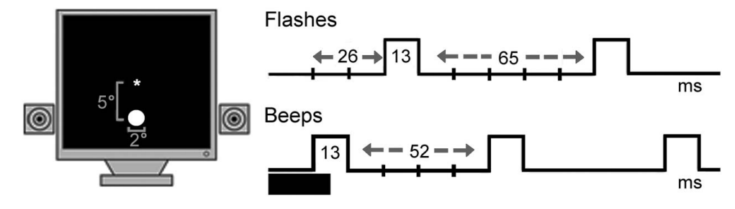
Figure 1. Experimental task. Configuration of flashes and beeps and their timing.
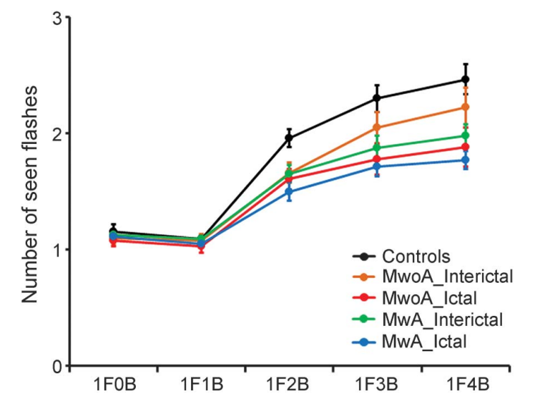
Figure 2. Fission illusion in migraineurs and controls.
Average number of perceived flashes (ordinate) and number of flashes (F) and beeps (B)
(abscissa) for each group (colored lines): controls, patients affected by migraine without aura
(MwoA) and with aura (MwA), tested during the interictal or ictal phases. Error bars: standard
error.
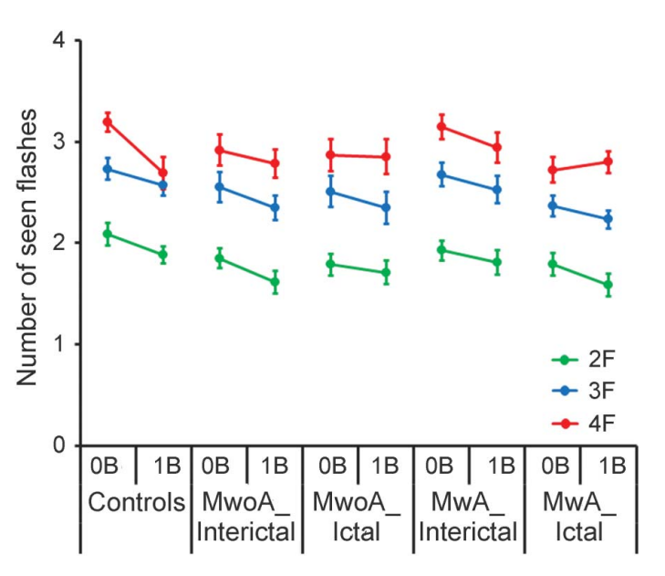
Fig. 3. Fusion illusion in migraineurs and controls.
Average number of perceived flashes (ordinate) by number of beeps (B) and flashes
(F, colored lines) for each group (abscissa). Groups and error bars as in figure 2. MwA 5
migraine with aura; MwoA 5 migraine without aura.

